IBM Coursera Capstone Project – The Battle of Neighbourhoods

V. A. Nguyen

April 19, 2020

Introduction – Business Case

A newly immigrated family to Toronto would like to open a French/Vietnamese bakery cafe where they would offer French pastries and Banh Mi sandwiches. Back in their home country, they operated a bakery successfully but being new to Canada, they need advice on the best location for their new venture.

Toronto is a dynamic city with an amazing food culture allowing many restaurants and coffee shops to thrive. There are plenty of Asian food businesses offering everything from Japanese sushi to noodle soups such as Vietnamese pho. There are well-established neighborhoods such as Yorkville but also up-and-coming ones such as Distillery District.

The family’s bakery will offer coffee, pastries and banh mi sandwiches for take-outs with some seatings available. They know their clientele - young urbanites who want delicious banh mi sandwiches, coffee and pastries convenient and fast! The family also feel that they can deliver on volume sales to maximize profit so being in a young neighborhood with population density will be a plus.

Picking the right location with a middle-class population density will ensure the family’s chance of success.

So, I will use Data Science to analyze Toronto’s neighborhoods to help the family make the decision.

Foursquare Location Data will be used in this project to gather information on bakeries. I will also gather other pertinent data about the neighbourhoods of the City of Toronto from Wikipedia.

Data

Wikipedia - Information on Toronto neighbourhoods

Produce map of Toronto with different neighbourhoods

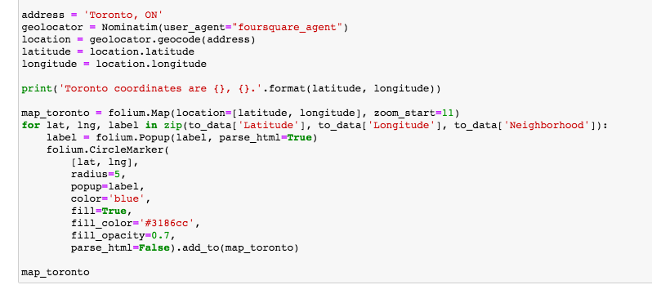

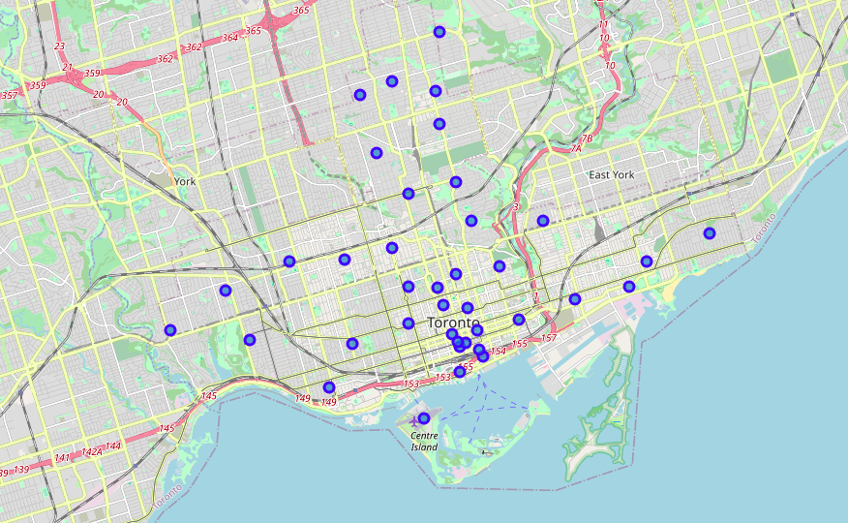

Foursquare API - Collect information on bakeries in the neighborhoods of Toronto.

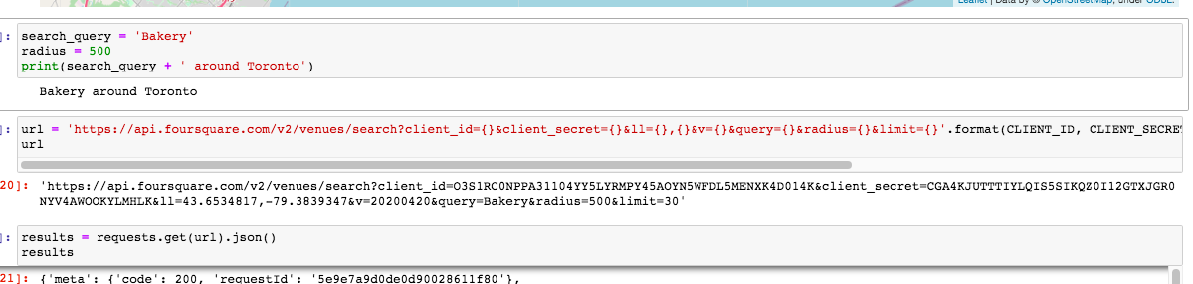

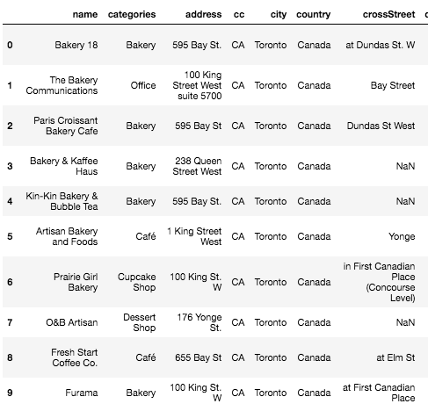

Methodology

To find the most suitable neighbourhood for the family’s bakery, we explore the different areas of Toronto and its demographic data such as population and density.

Data Analysis - Data is filtered and neighbourhoods are sorted by descending population. We can see that Old East York has the highest population and one of the highest density.

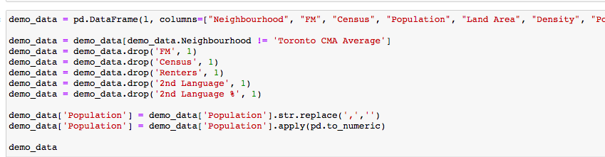

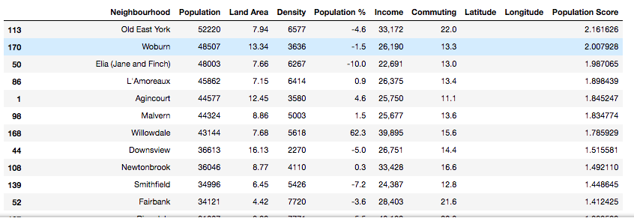

Results

Based on the family’s requirement for a neighbourhood with high population also the bakeries around Toronto, two options stand out:

Old East York neighbourhood which has biggest population of 52,220. It also has few bakeries which offer French pastries and banh mi!

Discussion

As the family insists on selling their baked goods on volume, the recommendation would be to set up their bakery cafe in Old East York neighbourhood.

Conclusion

This analysis is not conclusive as of today (April 21, 2020) due to the Covid-19 pandemic situation. Many small businesses will not survive, including bakeries. This means that the family may have more options for their business, including buying an existing one.